PHASE 6 – Creating Widgets and Adding Them to the Page
Create two custom Service Portal widgets and place them on the Employee Center page to provide an informative section and a Raise an Issue entry point.

Widget 1 – Commercial widget
Create a widget named Commercial widget in Service Portal Configuration → Widget Editor. Add the supplied HTML and CSS code from the project specification. Use Enable Preview to verify the appearance before saving.

Widget 2 – Link redirect
Create a widget named Link redirect. Add the supplied HTML and CSS. Add the Client Script to redirect users to the Raise Employee Issue Record Producer.

Important Client Script
Replace RECORD_PRODUCER_SYS_ID with the sys_id of the Record Producer created in Phase 4.

Adding Widgets to the Page
1. Open Service Portal Configuration → Designer.
2. Select the Employee Center homepage/page used by the project.
3. Create a 6×6 container/column layout as required.
4. Search for the created widgets.
5. Drag and drop Commercial widget and Link redirect into the required positions.
6. Save and preview the page.

Code Location
The HTML/CSS/Client Script supplied in the project notes can be pasted into the corresponding Widget Editor sections. Keep the existing project code unchanged except for replacing the Record Producer sys_id.
Widget Editor
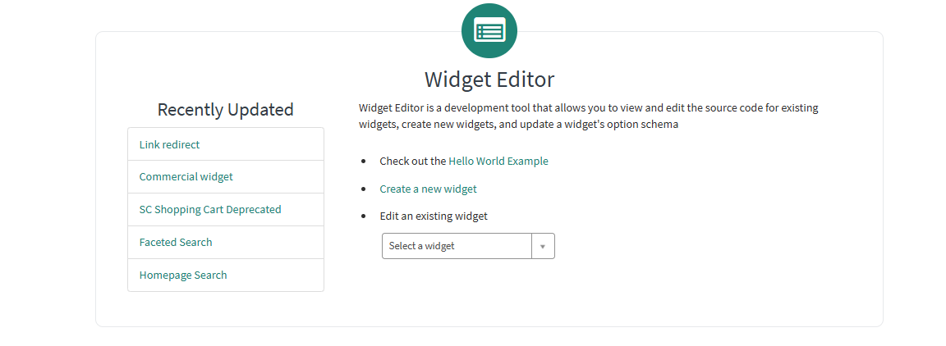
Commercial widget HTML/CSS
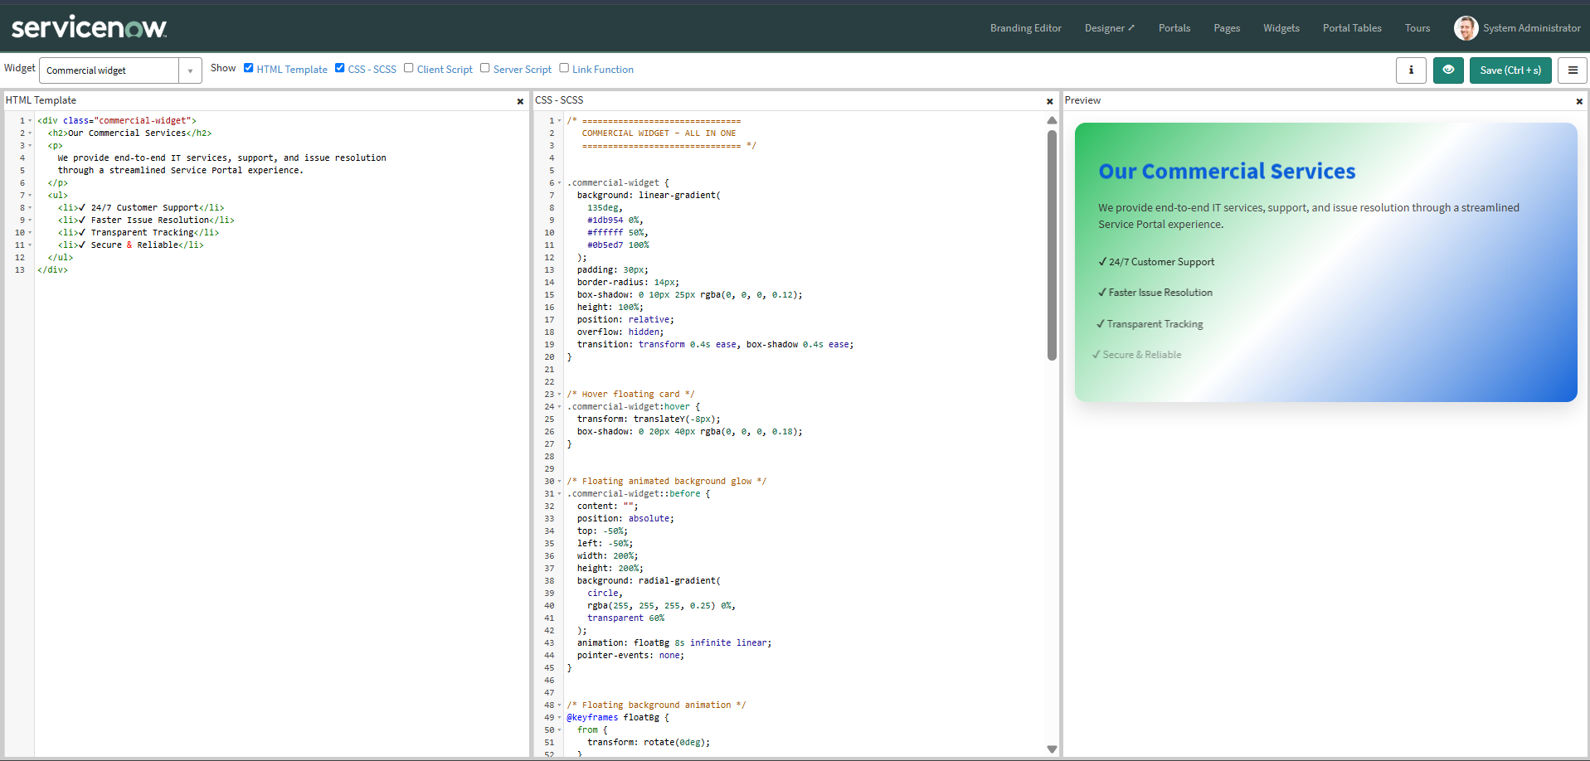
Link redirect HTML/CSS
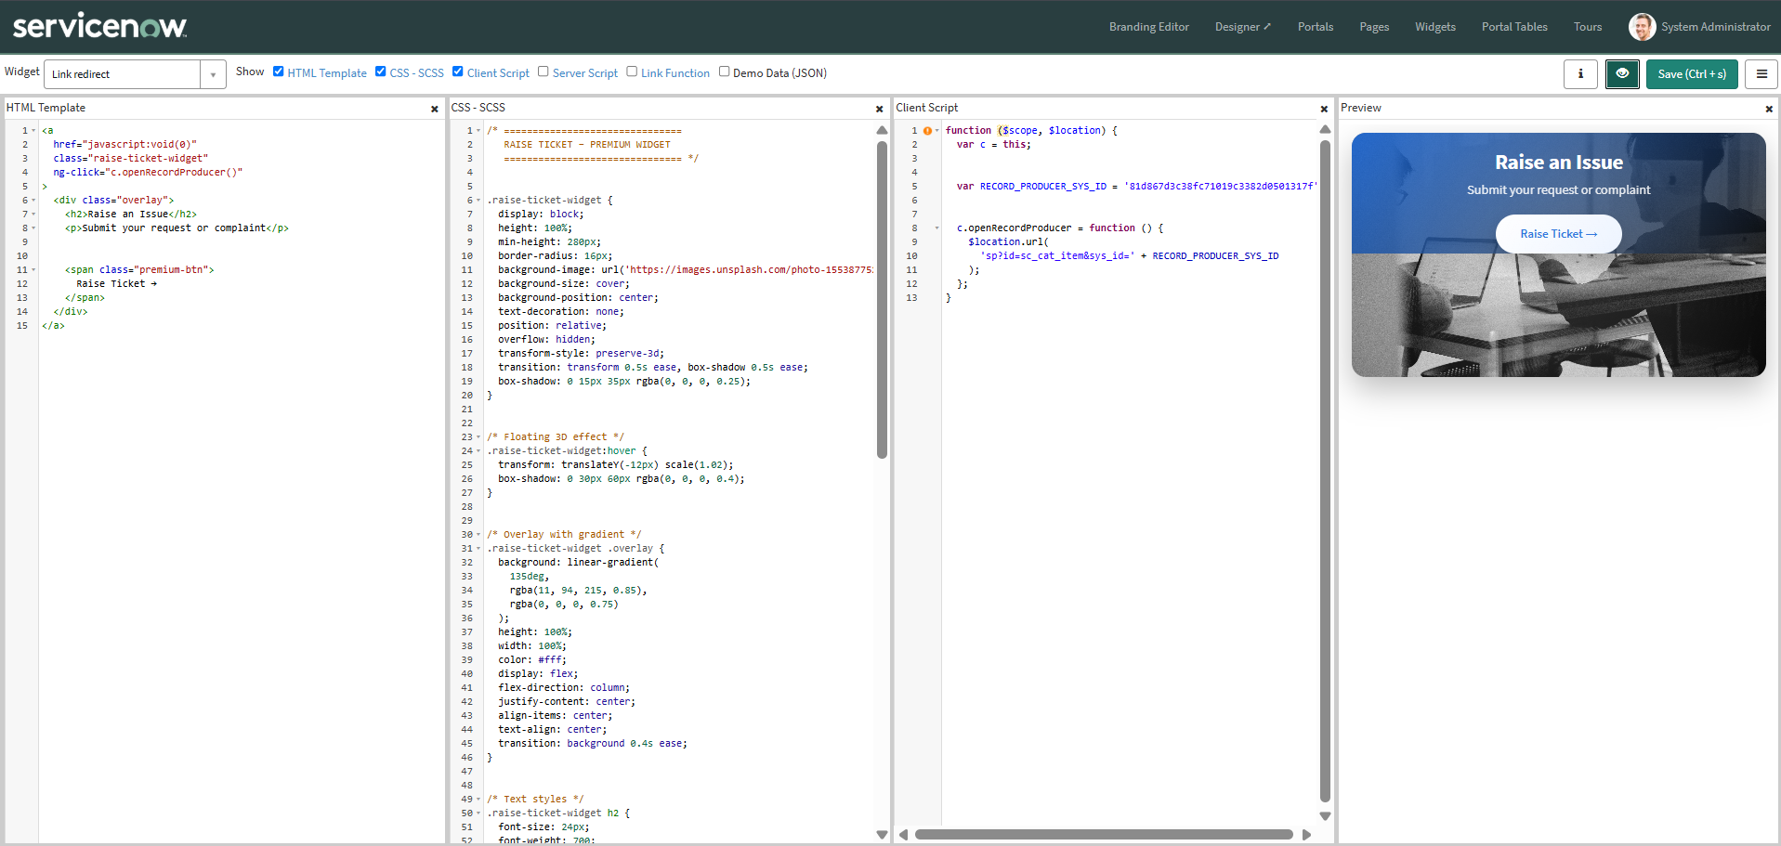
Page Designer with both widgets
